04.01
Company organisation
Process Design & AMOS Configuration Document
Purpose
This Process Design document is provided to Key-Users to record their key decisions regarding the AMOS Process design and the required AMOS configuration.
It is updated throughout the Project Definition Phase and used as the baseline for the Final Acceptance prior to Go-Live
Revision
Author, Name | Date | Notes
Swiss-AS, Consulting | 01.06.2024 | First Version
Dimitri Dupont | 03.12.2024 | 01
Jakub Sadowski | 01.06.2025 | 02 (Visio flowchart update)

Table of Contents
1. Process Overview & Objectives 3
2. Regulatory References 3
3. Definitions & Glossary 3
4. Process Tasks 3
5. Process Dependencies 4
6. Process Flow 5
7. Process Design Questions 7
8. Data Source Mapping 11
9. Other Software Used 11
10. AMOS Configuration 12
a. Process specific configuration programmes 12
b. Basic Data 12
c. Parameters 13
d. Workflows 15
e. Scheduled Tasks 15
f. API’s & Interfaces 16
11. UAT Guidance 17
12. Annex – Additional Info 17

Process Overview & Objectives
Process General Description:
This process describes the creation of physical and organizational structure in AMOS.
Main Process Objective (Outputs & Outcomes):
This is a “one-time” process i.e., that once done, unless there changes in the company organisation will remain as is throughout the usage of the system. To the different elements of the organisation are linked some properties. The adequate assignment of this properties has a cascade effect throughout AMOS various processes such for example as financial aspects or repair management modules.
It is recommended that the internal organisation of the company is reflected in AMOS Address Administration.
Hangars should be also added, as required, in order to use possibilities described in the Process 07.02 -Hangar & Resources.

For AMOS and the Finance ERP system interfacing, refer to BP 12.01.

Regulatory References
- EASA 145.A.15 Application for an organisation certificate
- EASA 145.A.70 Maintenance Organisation Exposition (MOE)
- EASA CAMO.A.115 Application of an organisation certificate
- EASA CAMO.A.300 Continuing Airworthiness Management Exposition (CAME)

Definitions & Glossary
Key-Words | Explanation
Item | Main address of an organisation
Sub Item | Organisation’s different addresses
Address | AMOS Addresses represent different types of entities; Vendors, Suppliers, Customers, Stations, Stores, Aircraft OEM’s, Regulatory Authorities
Station | A station is a property assigned to a type (Main Address, Department, place..) of an item / Sub-item.
Store | The store property must be assigned to an item/sub-item if it is foreseen that this address will host a store location
Internal Shop | An internal shop property must be assigned to an item/sub-item if it is a shop or contains a shop. If an address contains multiple shops, each additional shop shall be defined as Internal Shop.  This property is mandatory to perform component maintenance to perform in house repairs.
Certificate | A certificate can be internal (internal Approval) or external, i.e linked to an authority approval (with the adequate Certificate number)

Process Tasks
Business Process Task / Actions / Activities:
- Create addresses:
The addresses created in this process should reflect the company organisation. This includes the different departments, shops, hangar, etc...
- Assign Properties
Once the address created, it is necessary to assign the adequate properties (i.e. Station, Store, internal Shop, operator etc...) and, certificates as required. For the organisation main address, it is mandatory to assign the applicable currencies and account.

The address code used for the department in the Address Administration (APN 53) should the same as the Department Code defined in Basic Data Administration (APN18) Table “Department” that a correlation can later be made during the creation of the employees in Staff Management (APN: 146) in the field Department.

Process Dependencies
INPUT | CONCURRENT | OUTPUT
04.02 – Maintenance Agreements | -/- | - 01.01 – Aircraft definition  - 01.02 – Parts definition  - 01.03 – Aircraft Maintenance program  - 01.04 – SB & AD assessment  - 01.05 – Configuration Management  - 01.06 – MEL administration  - 01.08 – Weight & Balance  - 02.01 – Aircraft Phase in  - 02.02 – Aircraft Phase out  - 03.01 – Planning  - 03.02 – Work package Generation  - 03.06 – Long term planning  - 04.02 – maintenance Agreements  - 04.05 – Quality auditing  - 05.02 – Pilots Reports  - 05.06 – Flight Simulator training  - 06.01 – Fleet status monitoring  - 07.01 – Shift Planning  - 07.02- Hangar & Resources  - 07.04 – Production Plan Preparation  - 07-05 – Resource & Staff Allocation  - 08-02 – Performing maintenance.  - 08.05 – Maintenance Release to Service  - 09.01 – Material Planning  - 09.03 - Ordering  - 09.04 – Repair & Exchange  - 09.07 – Outstations & MRO’s  - 10.01 – Logistics  - 10.06 – inventory & Shelf Life control  - 11.01 – Capability List  - 11.03 – Shop Planner  - 11.06 – Component Release  - 12.01 – Financial Accounting

Process Flow
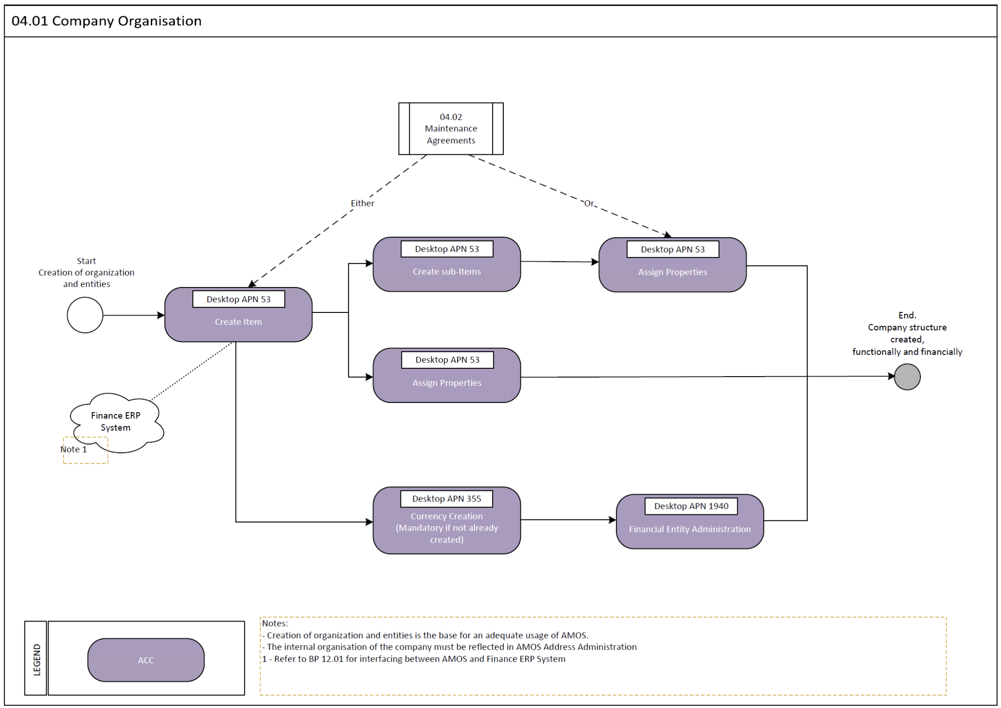

Process Design Questions
# | Question | Answer
1 | What will be the structure of the internal address tree?
2 | In which system will the addresses be created, ERP Finance System or AMOS?
3 | Which department will be responsible for creation of addresses in AMOS? Will it be the same department responsible for the creation of the organisation own tree structure?
-/-

Data Source Mapping
Data Sources | Description | Volume / Manual / Automatic / Static / Dynamic
-/- | -/- | -/-

Other Software Used
Other Software | Used by: | Description
ERP Finance System | Finance Team | Interface to be defined. Refer to BP 12.01
-/- | -/-

AMOS Configuration

Process specific configuration programmes
AMOS APN | Notes
-/- | -/-

Basic Data
Basic Data Table | Notes
Address Certificate Type | Create the certificate type that are going to be used throughout the organisation or vendors/suppliers/Maintenance Providers.
Address Communication Type | Communication type creation
Address Property Type | Properties definition and creation.
Address Type | Type of addresses definition and creation
Department | Repository of all the different departments of the customer company

Parameters
Parameter Code | Parameter Name | Notes
1438 | ENABLE CREDIT LIMIT CHECK
1595 | ENTITY RELATED ACCOUNTING

Workflows
Workflow Number | Workflow Name | Workflow Setup Notes
161 | New Address Stored
162 | Address property Stored
34 | Request Cert. Approval
35 | Deny Cert. Approval
36 | Confirm Cert. Approval
37 | Renew Cert. Approval
229 | Address saved (pre-save)
453 | Address saved (post-save)

Scheduled Tasks
Scheduled Task Reference | Frequency | Notes
-/- | -/-

API’s & Interfaces
Reference | Direction | Trigger | Frequency
-/-

UAT Guidance
Test case number | Test case description | Required data | Required resources
1 | Main Company Address creation (item) | Main address | ACC
2 | Creation of sub-item |  | ACC
3 | Assignment of a station to a sub-item |  | ACC
4 | Assignment of an internal shop to a sub-item |  | ACC
5 | Assignment of a store to a sub-item |  | ACC
6 | Revision of the address structure |  | ACC
7 | Assignment of an internal approval |  | ACC
8 | Assignment of an external approval |  | ACC
-/- | -/-

Annex – Additional Info
-/-

